Canadian Farm Writers’ Federation

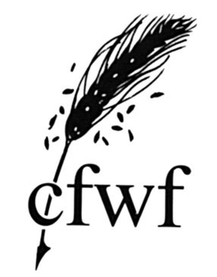

2011 Annual Report

Presented to the CFWF 2012 Annual Meeting
By conference call

Thursday, August 23rd, 2012

Canadian Farm Writers’ Federation

2011 Annual Meeting

3:00pm
Thursday, August 23rd, 2012
By conference call
1-866-613-5223
Access code 6943560#

Agenda

1. Welcome

2. Adoption of the agenda

3. Adoption of the minutes of the 2011 annual meeting

4. Business arising from the minutes

5. President's Report

6. Secretary-Treasurer's Report and Financial Statement

7. Conference Reports

8. Awards Program Report

9. IFAJ Report

10. Regional Reports

11. Senate Report

12. New Business

13. Board Elections

14. Adjournment
Canadian Farm Writers’ Federation

Minutes of the 2011 Annual Meeting

Tuesday, August 30th, 2011 at 3:00pm EDT
By teleconference

- Welcome
Myrna Stark-Leader called the meeting to order at 3:10 pm and welcomed everyone. Hugh Maynard apologized with the mix up for the access code for the conference call line.
2. Adoption of the Agenda
Janet Kanters moved adoption of the agenda as presented. Seconded by Annemarie Pedersen.
Carried
- Adoption of the minutes of the 2010 annual meeting
Lilian Schaer noted that she was not present for the IFAJ report, and it was noted that Myrna made the Saskatchewan conference thank you’s, not Annemarie.
Reg Norby moved the minutes of the 2010 annual meeting be adopted as corrected. Seconded by David Scmidt.
Carried
- Business Arising
There was no business arising from the previous minutes.

- President’s Report
Myrna Stark-Leader presented a summary of the business for the year (see full report below). She noted that it had been a great year, this all being due to the people involved, and she thanked everyone for taking the time to participate in the teleconference meeting.

- Secretary-Treasurer’s Report and Financial Statement
Hugh Maynard presented the summary of items from the secretariat including the administration of the awards program, website and listserves, and the publication of the Farm Journalist newsletter. Having a summer student for a second year helped considerably.

Financial Statement
- Both income and expenses were very close to the budgeted amounts
- Big change was inclusion of sponsorships of IFAJ
- Membership revenue stable
- The Financial Statement has been reviewed by the Board as well as a third party bookkeeper.
A question was posed on whether it would be necessary to continue with GST ($50K threshold) after IFAJ was over; it may not be necessary but may be advantageous to continue given that CFWF receives no government funding so receives full tax refunds on expenses. Another question was on why the FJ honorarium was not paid in 2010; it was explained that it was offered on an annual basis but not always accepted. It was agreed that there should be an explanatory note in the financial review when this happens.

Hugh Maynard moved to accept the revised 2010 Financial Statement, seconded by Glenn Powell. Carried

Hugh Maynard moved that Flo Johnson review the financial records for 2011, seconded by Lisa Guenther. Carried

Hugh Maynard briefly reviewed the 2011 financial status and budget for information purposes.

- Awards Program Report
Felicity Feinman, Awards Coordinator, compiled a report on the awards program. The 182 entries received was down from the previous year, presumably due to the postal strike. The press feature category once again was the largest with and radio and TV continue to struggle. There continued to be a wide variety of judges from across North America to assist in the judging process. It is a continuing challenge to maintain sponsorship for individual awards and one category remained unsponsored. The awards presentation will be held during breakfast on the Saturday of the IFAJ Congress.

- IFAJ Report
The 2011 Conference will be hosted by ECFWA in Guelph and Niagara Falls, ON as part of the IFAJ 2011 Congress. Co-chair Lilian Schaer gave a brief overview of the location and anticipated activities including 260 participants from 30 different countries with 92 Canadians and 35 US farm writers attending. She noted that the tours were sold out and that there was no more room in the 3 Guelph hotels, 130 people had signed up for the Outdoor Farm Show and the two pre-tours in BC and Atlantic Canada were full as well.

Allison Finnamore, the CFWF representative to the IFAJ Executive, gave the report. She reviewed the program offerings and activities and reflected on her first meeting in Berlin and getting to know the organization better.

Tamara Leigh gave a brief report on the Monsanto IFAJ bursary, noting that there were 19 applications with Megan Oleksyn being selected as the winner to receive the $2500 bursary to attend the IFAJ Congress in Guelph. She noted that there would be no competition next year as John Greig would be attending the Swedish congress in lieu of his volcano-interrupted trip to Belgium in 2010. The 2013 bursary will send the winner to Argentina.

- 2012 Conference Report
Maureen Fitzhenry gave a brief update of the upcoming conference in Winnipeg. Myrna Stark-Leader reported on the 2010 conference providing information on the participation and sponsorships, in particular the very high number of registrations. Myrna identified each of the host committee members and gave a brief description of their contributions to the conference.

The 2011 Conference will be hosted by ECFWA in Guelph and Niagara Falls, ON as part of the IFAJ 2011 Congress.

Conference rotation is as follows:
2011 EC (IFAJ)
2012 MB
2013 BC
2014 EC
2015 AB
2016 SK

- Regional Reports
Written reports contained in the handout. Regional representatives provided a brief overview.

- Senate Report
Tabled to the evening banquet. Senators to meet in the bar at 5pm to prepare.

- New Business

By-Laws
Hugh Maynard explained that although CFWF had amended its by-laws in the previous year to be compliant with Industry Canada requirements for incorporation, it was necessary to make further (minor) amendments at the request of the department.

Hugh Maynard moved to accept the proposed by-law changes, seconded by Crystal Jorgensen. Carried

Atlantic Canada
Allison Finnamore provided background on the creation of the Atlantic Canada Farm Writers Association (ACFWA) to represent agricultural communicators in New Brunswick, Nova Scotia, Prince Edward Island and Newfoundland & Labrador. The new association had sent a letter of application to the CFWF board of directors to join CFWF as a regional association, as required by the by-laws, which had been accepted.

David Schmidt moved to accept the request of the ACFWA to join CFWF, seconded by John Greig. Carried

- Board Elections:
Owen Roberts chaired elections process. Hugh Maynard informed everyone of the process according to the constitution.

- On behalf of BCFWA, David Schmidt nominated Tamara Leigh as their representative on the CFWF board
- On behalf of AFWA, Clare Stanfield nominated Annemarie Pederson & Alexis Kienlen as their representatives on the CFWF board.
- On behalf of SFWA, Lisa Guenther nominated Myrna Stark Leader as their representative on the CFWF board
- On behalf of MFWBA, Crystal Jorgensen nominated John Morris as their representative on the CFWF board
- On behalf of ECFWA, Karen Dallimore nominated Kelly Daynard and Clare Illingworth as their representatives on the CFWF board
- On behalf of ACFWA, Wayne Riley nominated Allison Finnamore as their representative on the CFWF Board

Members at Large –
- Marlene Hursh nominated Lisa Guenther as the western representative.
- John Greig nominated Hugh Maynard as eastern representative.

Owen Roberts closed nominations, all nominees accepted.

- Adjournment:
Ron Friesen moved adjournment at 8:21 am.

Annual Reports

President’s report
Prepared by Tamara Leigh

What a year! Following the outstanding success of the 2011 IFAJ Congress in Ontario, CFWF has been abuzz with activity.

Hosting the IFAJ Congress had a significant impact on our association. Preparing to host it gave us focus and cause to pull up our organizational socks and get official in the eyes of government. The event itself sparked new energy in our members, and made many of us aware of international opportunities for work and partnership. Even our members who were not able to attend will benefit as the financial profits of the Congress are shared nationally and regionally.

This year, CFWF used legacy funds from IFAJ to pilot a series of professional development webinars. A dedicated sub-committee developed ideas and sought speakers that would be able to present topics of interest to our journalist and communications members. The three sessions drew participants from across the country, and allowed us to engage members in a new way. The initiative was well received, and will likely continue in the coming year.

As with so many things at CFWF, we could not have done it without the hard work and dedication of our Secretariat, Hugh Maynard and Christina Franc. These two people are the engines of our organization, and I cannot thank them enough for the work that they do.

I am also honoured to work with a dedicated board of colleagues from across the country. These people are your voice, and provide invaluable guidance at the national table. If you have ideas, please don’t be shy about contacting your regional representative or any member of the executive.

The opportunities afforded by the our connections with IFAJ have also highlighted the need to consult with our members about where you would like to see our organization go, and what other activities you would like us to pursue and develop. To that end, the CFWF Executive will be hosting a breakfast meeting on Saturday at the conference in Winnipeg.

I would like you to invite each of you to join us for this meeting to share your ideas for how you would like to see your organization reinvest the proceeds of the IFAJ Congress, improve value and services to members, and ensure that every member has the opportunity to participate in international activities. There will be coffee and stimulating conversation.

In service and gratitude,
Tamara Leigh
CFWF President
Secretary-Treasurer’s Report
Prepared by Hugh Maynard

Administration
The 2010-2011 year was pretty exciting from an administrative perspective – not just a little bit of paperwork here, a little there, a few cheques to write and so on but a whole international conference to process post-event! CFWF’s administrative coordinator, Christina Franc, returning from her international internship in London, UK last year, took over the administrative reins, in particular guiding the Secretariat through the maze of HST regulations that make no sense at all to the average person. A medal for her patience is due at the very least.

She also took on the conversion of the awards program to electronic entries, which was a major success with few glitches, as well as saving CFWF a few thousand dollars for years to come (our apologies to Canada Post), coordinated the first professional development webinars and took over the helm of the FJ, initiating at the same time an e-newsletter version of the venerable farm writer’s publication.

Christina was ably supported by Felicity Feinman, CFWF’s second summer student employed through a Young Canada Works grant. Felicity contributed to the awards program and membership activities. Felicity, like Christina, is a journalism student at Carleton University. Many thanks to both of them for all the work they did in the past year ensuring that we had well functioning organization and a quality newsletter.

The holding of the business part of the annual meeting by conference call was judged by participants to a great success and so it has been organized again for 2012. This will ease the pressure on the Saturday morning schedule at the conference and allow for some more substantive discussion on matters of more interest to farm writers than annual reports. The CFWF Board didn’t meet in person at the 2011 Congress given the change in the usual conference schedule but did meet three times by conference call – a good time was had by all.

Membership
Membership numbers stayed steady for 2012 at 344, on par with the past few years.

Finances
The bank balance remains healthy due to the generous contribution of sponsors and excellent fiscal management of the organizing crew for the 2011 Congress, and the support for Secretariat activities through the YCW summer student grant. Although the final determination of the Congress surplus is still pending due to the HST rebate, CFWF has a good surplus on hand with which to continue to support networking and professional development activities. This will allow continued contributions towards support activities such an official delegate to IFAJ meetings and purchase of liability insurance which covers regional association activities as well. CFWF filed its first ever GST/QST claim in 2011 and received a modest rebate on its operational expenditures. Additional details can be found in the following section on the financial statement.

Conference Planning
As per the conference schedule adopted in 2004, the rotation has been adapted to accommodate ECFWA hosting every third year (instead of every second one); Atlantic Canada has indicated that it will host in 2014 in place of EC.

2012 MB 2017 EC 2022 SK
2013 BC 2018 MB 2023 EC
2014 AC 2019 BC 2024 MB
2015 AB 2020 EC 2025 BC
2016 SK 2021 AB 2026 EC
CFWF Financial Review 2011
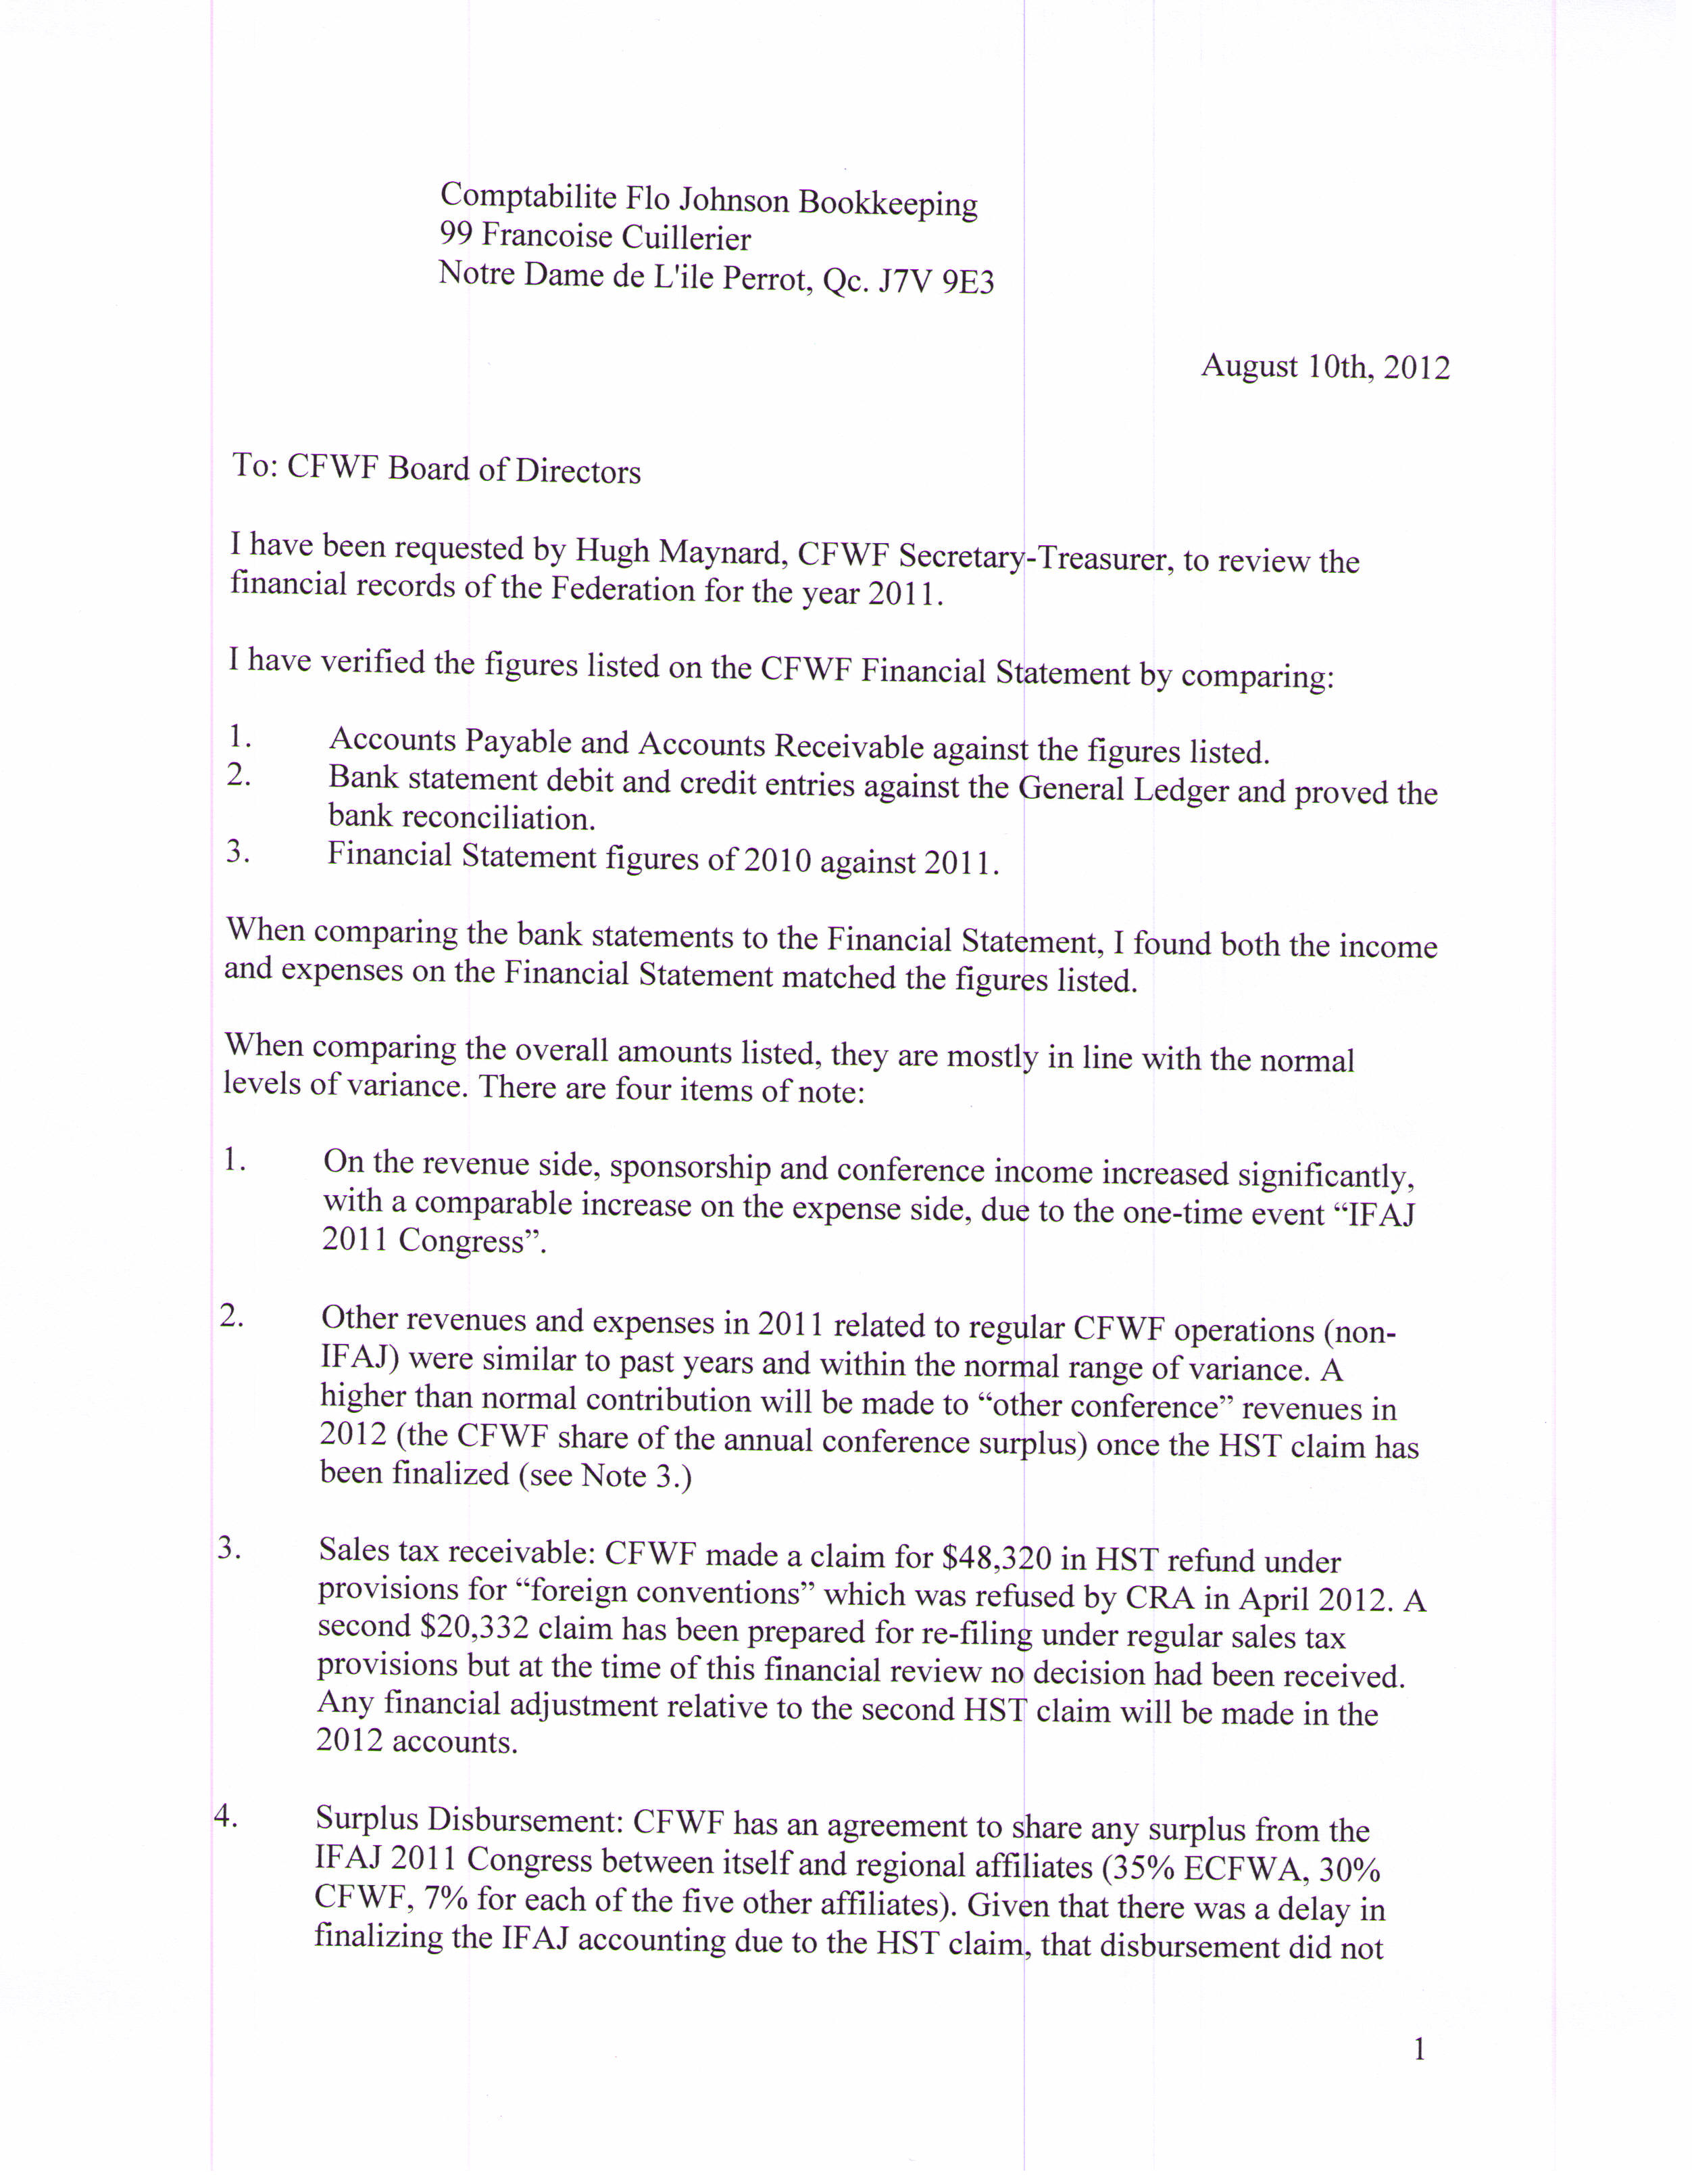
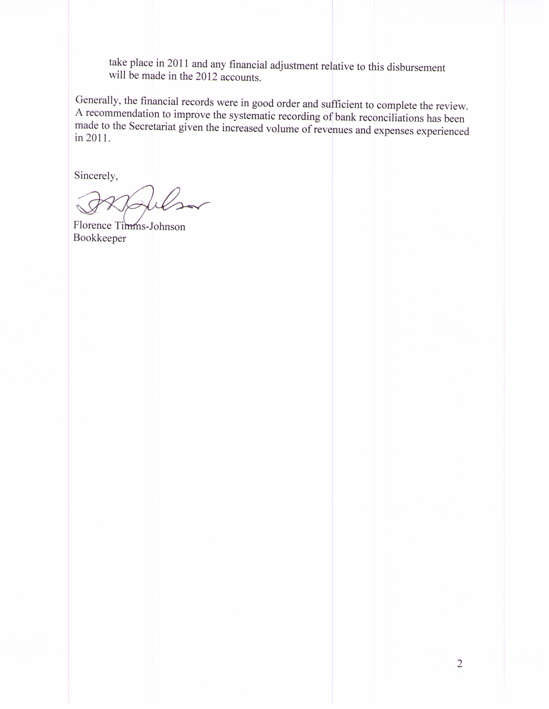
CFWF Financial Statement 2011

2010 2011

INCOME

Awards Fees $ 4,230 $ 3,730
Sponsors $ 10,000 $ 10,800
IFAJ Bursary $ 2,505 $ 2,500
Conference Registrations $ 300 $ 393,386
Sponsors $ 0 $ 348,000
Other $ 89,251 $ 0
Memberships $ 10,740 $ 10,861
Interest $ 2 $ 3
Other $ 6,772 $ 4,797

TOTAL INCOME $ 123,800 $ 774,078

EXPENSES

Administration Admin-Coordinate $ 9,856 $ 9,612
Conf. calls $ 253 $ 293
Insurance $ 3,950 $ 2,874
Other $ 1,406 $ 3,082
Awards Administration $ 3,191 $ 2,127
Certificates $ 1,268 $ 906
Judging $ 1,300 $ 1,125
Prizes $ 8,425 $ 7,950
Refunds $ 0 $ 20
IFAJ Bursary $ 2,500 $ 1,740
Conference Expenses $ 81,946 $ 648,376
Farm Journalist Honorarium $ 0 $ 0
Travel $ 0 $ 1,000
IFAJ Fees $ 3,320 $ 3,659
Congress rep. $ 1,631 $ 1,472

TOTAL EXPENSES $ 119,046 $ 684,236

TOTAL INCOME/EXPENSE $ 4,754 $ 89,841
CFWF Balance Sheet - 2011

2010 2011

ASSETS

Current assets
Chequing $ 20,434 $ 124,810
Accounts receivable $ 10,649 $ 2,832
Pre-paid expenses $ 906 $ 1,233
Undeposited funds $ 20 $ 20
________ _______
Total current assets $ 32,009 $ 128,895

Total Assets $ 32,009 $ 128,895

LIABILITIES & EQUITY

Current liabilities
Accounts payable $ 21 $ (34,831)
Other liabilities $ 0 $ (19,388)
________ ________
Total current liabilities $ 21 $ (54,219)
________ ________
Total Liabilities $ 21 $ (54,219)

Equity
Opening balance $ 16,296 $ 16,296
Retained earnings $ 10,938 $ 76,977
Net income $ 4,754 $ 89,841
________ _______
Total Equity $ 31,988 $ 183,114

Total Liabilities & Equity $ 32,009 $ 128,895

Additional Financial Notes:
Because of the one-time increase in revenues and expenses related to the IFAJ Congress, the financial statement for 2011 is difficult to compare with previous years. Also, given the refusal and then re-submission of the HST claim, the final outcome of the IFAJ surplus will only be determined in the 2012 statement. Therefore a separate ‘side statement’ has been provided so that members can review the CFWF financial statement without the IFAJ Congress items.

In summary for 2011:
- CFWF (non-IFAJ Congress) revenues and expenses were $32, 691 and $35,859 respectively, for a deficit of $3,168. The deficit was all due to the fact that there was no contribution from the annual conference surplus as in past years. This will be compensated for in 2012 when the initial transfer of surplus from the IFAJ Congress will result in a minimum contribution of $15,000.
- The cash surplus from the IFAJ Congress (without any adjustment for sales taxes) is currently $72,225. The surplus was generated, in addition to prudent fiscal management by the organizing committee, by a generous downward adjustment on behalf of one of the hotels (after the Congress was finished) to penalties that were otherwise due on unfilled room allocations, and a number of last minute sponsorships and registrations. The IFAJ organizing committee recommended that $50,000 of the surplus be distributed to CFWF and regional associations as per the agreement for sharing any surplus funds. The remainder ($22,225) will be distributed along with any additional funds from the HST claim once it has been settled.
- The revised HST claim is for $20,332. While it is substantially less than the initial claim, there is still the possibility it could be revised downward again depending on the CRA’s assessment of “exempt” and “zero rated” revenues.

Awards Program Report
prepared by Christina Franc

This year I was back on board to organize the CFWF awards program. Being quite tired of the paperwork associated with it (think 200 entries x 3 copies each + 1 entry form per submission + postage to/from judges…it adds up), but more importantly based on feedback from both members and judges, the secretariat decided to switch things up a bit with an electronic submission process.

There were a few bumps in the road along the way, some bigger than others, but overall, the new system was a huge success! We started by using Moodle (a free e-learning platform) but after running tests with a few brave CFWF volunteers, the disadvantages outweighed the opportunities. So we switched to an online survey software called Wufoo that allows for automatic payments, file uploads and the form could be directly embedded on our website. Although, as mentioned, there were a couple more bumps that we’ll be working to improve next year, including easier file uploading (quite a few people had trouble, often it was because the file size was too large, tsk tsk to those who didn’t watch our handy demo videos) and a ‘group’ upload option for organizations like Ontario Farmer and FBC who have one person submit several entries for several people.

We had people complete a survey on the new process and overall everyone was very happy with it. Feedback included the above-mentioned ‘bumps’. Despite those, all but one surveyed said they preferred the digital process because it saved time (average time to complete was 30 minutes) and money (postage, photocopies, etc).

There’s a bit more behind-the-scenes work to be done for next year but the entry process will be entirely digital. This year, of the 214 entries submitted, only 3 were hard copies mailed to us. We saw the highest increase in submissions since 2008 (221 entries) and hopefully with the new online process, that number will steadily increase. As per usual, the two strongest categories were technical feature and press feature. Daily press reporting is holding steady with 4 entries and with the advent of electronic entries comes electronic video and audio submissions so those categories are seeing subtle increases, a trend that will hopefully continue. Finally, the website category almost doubled this year, demonstrating its increasing popularity.

Our judges, as always, come from far and wide and were just as eager to participate in the new online process we’ve set up. About half our judges were returning from last year, with the other half coming from across North America with varying degrees of expertise in agriculture and their coordinating category.

Thank you to both our new and old sponsors for your support of the awards program, we had two new sponsors step up to the plate (CanWEA and Dairy Farmers of Canada) along with our dedicated long-term sponsors. For a full list, be sure to pick up a brochure at the awards banquet.

Finally, a big thanks to Felicity Feinman, who was hired with Young Canada Works full time again to work as a summer student for CFWF, she has been my right hand woman through it all, taking special care of the judges and sponsors.
International Federation of Agricultural Journalists (IFAJ)
By Allison Finnamore, CFWF representative to IFAJ

Writing this report is one of my last work-related chores to do before I leave for the 2012 IFAJ congress in Sweden, so I launch in to this report with excitement (and the urge to finish packing).

In January, I travelled to Berlin, Germany for the annual IFAJ executive meetings. This environment provides a retreat-like atmosphere for the executive and the meetings, although making for long days, are an excellent opportunity to focus on the organization. We are fortunate that hotel expenses are covered by Messe Berlin, the host of International Green Week, the food, agriculture and cultural festival held at the same time as our meetings.

Overall, feedback for IFAJ 2011during my Berlin visit was very positive. There were some concerns raised about the closing banquet/awards ceremony, however, a plan was put in place for the secretary general to work with the host country organizing committee to refine the awards presentations. As the evening is largely made up of IFAJ-related business, the local organizing committees are limited by the structure, but every year is a learning experience.

At the 2012 IFAJ Congress, awards are scheduled to be presented at various times throughout the congress as special effort is made to continue to celebrate the winners, honour the sponsors and showcase the winning entries.

IFAJ continues to move forward with a strategic plan with the goal of creating a more global organization. This will be discussed in more depth at the delegate assembly at the 2012 congress and will be brought to members for a vote.

I was pleased to see the launch of the Exposure-4-Development media tour, set for November to Kenya. What an exciting program! During the development process, I helped design the application form and point system that was refined and implemented for this inaugural year.

Once the framework was done and a system in place, the call went out nationally to all member countries for applications. As each IFAJ member country was able to put three names forward for international judging and we had six CFWF applications, an ad hoc judging panel was formed, selecting Tamara Leigh of British Columbia, Anne Lazurko from Saskatchewan and Frances Anderson of Ontario. Tamara Leigh was chosen internationally as one of the 13 applicants to attend the media tour in Kenya.

I do encourage the unsuccessful applicants to apply again next year, in addition to anyone else interested in participating.

Nearly simultaneously, the application process started for the IFAJ-Alltech Young Journalist's Boot Camp competition. Three applications were received for this awards program and Alexis Kienlen was the successful application to move forward to the international round of judging. And she was indeed a successful applicant internationally and will be in attendance at the Boot Camp professional development in Sweden.

A hearty, sincere congratulations to both Tamara and Alexis for these successes.

I'm always willing to answer questions any CFWF members may have about IFAJ, membership benefits, contests, applications or plans. Please contact me at 506-860-7761 if you have any questions at all.

Respectfully submitted,

Allison Finnamore
CFWF's IFAJ representative

Regional Reports

British Columbia Farm Writers’ Association
Prepared by Tamara Leigh, BCFWA Representative

In British Columbia, activity is picking up as we prepare for CFWF 2013 at the Harrison Hot Springs Resort in scenic Agassiz, BC.

In January 2012, BCFWA hosted one of the best-attended AGM’s in our history. The evening featured a guest panel that spoke to the challenges of communications in BC’s agriculture industry. Guest speakers, Geraldine Auston of Auston Consulting, Kevin Boone, executive director of the B.C. Cattleman's Association, and Robin Smith, executive director and CEO of the B.C. Dairy Association, presented their perspectives on how their challenges and approaches differ communicating with producers and with media.

It was a lively evening of conversation and networking, and we even got a little business done. David Schmidt agreed to serve another year as our long-suffering president. Tamara Leigh continues as vice-president and the BC representative to CFWF. Jackie Stewart was confirmed as Secretary, and Sandra Tretick returned as Treasurer (at least for a while).

Our small and mighty troupe of west coast farm writers has seen a drop in membership this year with a number of retirements and two notable departures. In a move that many will envy, Sandra Tretick resigned from her position with Investment Agriculture Foundation and her role as BCFWA Treasurer in June to spend the next year sailing in Asian waters with her husband.

On a more somber note, longtime member, John Wilcox, passed away suddenly in June. John was a former columnist and contributor to Country Life in BC. He farmed with his partner, Sue Earle, at Duck Creek Farm on Salt Spring Island, and was a passionate advocate for community agriculture.

Anyone who works in agriculture can appreciate the cycles of life, death and renewal. Despite our sadness as we say goodbye to our friends, BCFWA is happy to welcome new member, Marcus Wong. Marcus was recently hired as the BC Dairy Association director of producer relations and communications.

Another highlight this year included the return of the Tim Armstrong Memorial Bursary in Agriculture and Journalism. The bursary is open to British Columbia students who are enrolled in the second year or higher of a full-time agriculture or journalism program at a university, institute or regional college in British Columbia or another province. This year, pre-veterinary student, Caitlyn Best received the $1000 award.

Mark your calendars for the next CFWF Conference, October 3-6, 2013. We’re looking forward to seeing you there!
Alberta Farm Writers’ Association
By Janet Kanters, AFWA Executive Director

The Alberta Farm Writers’ Association membership currently stands at 75 members.

Congratulations to AFWA member Alexis Kienlen who was one of 10 young journalists from around the world chosen for the 2012 Young Leaders award. The award allowed Alexis to attend the 2012 IFAJ Congress in Sweden this August.

The AFWA’s main activity this year was the annual tour/meeting, developed by Mary MacArthur and Janet Kanters, held June 6-8 in the Drayton Valley area. Twenty-five participants took part in our tour, which included stops at the Pembina Provincial Grazing Reserve, Cynthia Solar Aquatic Water Reclamation Facility, 100km Kitchen Company, Sekura Livestock Auctions, Breton Plots and the Breton Agricultural Museum.

Saskatchewan Farm Writers’ Association
Prepared by Myrna Stark Leader

Membership
Membership has increased once again from 48 in 2011 to 56 in 2012, which is good news.

Events
Members got together a few times this year beginning just after the 2011 CFWF meeting when members gathered for the annual meeting in Regina in November during Canadian Western Agribition. During this meeting, a new executive was elected, plans were made for a regional professional development and tour event to take place in the Saskatoon area, and the SFWA bursary, which is awarded to a member to help offset costs of attending the CFWF conference, was increased from $500 to $1,000.

On June 16, members headed north to Saskatoon for professional development. There were 15 paid registrants. The day began at the Western Producer boardroom with a session on how to get the most out of your photos with Roberta Wells. The group then travelled to the Western College of Veterinary Medicine and received a thorough tour of the facility. It was then off to Rosthern for a tour of the Horizon pet food plant and lunch at Rosthern Station Restaurant. That was followed by an educational stop at the Art Prium dairy farm. Art spoke at the 2010 CFWF conference in Moose Jaw so it was great to make the connection to the real place rather than simply powerpoint photos. The group returned to Saskatoon for a visit at Saskmade Marketplace. The final professional development session – how to start your own business – was led by Monica Krueger over supper.

On June 19, 10 members attended a mid-term meeting during the Farm Progress Show in Regina where regular business was discussed.

One of the challenges this year is that our President, Lindsey Smith, relocated to Manitoba. While she is currently a member in our province and will remain in her position as President, she will step down in November. In light of this, a new president will be elected or appointed at the AGM in November. In Lyndsey’s absence, Maureen Fitzhenry (Vice-Chair) will chair the AGM. Long-standing members attending the meeting believe that there could be more involvement in SFWA by new and past members who are working in agriculture. We encourage all that are interested to get involved.

At the time of writing, a call for an expression of interest for the annual SFWA bursary to help defer expenses to attend the 2012 national conference was still out.

As always, new members are welcome. Contact information for the executive is available on our website at www.saskfarmwriters.ca.

2012 Executive
President – Lyndsey Smith, Grainews (only until November 2012)
Vice-President – Maureen Fitzhenry, Canadian Wheat Board
Secretary – Jan Coté, Agriculture & Agri-Food Canada
Treasurer – Marlene Hursh, Hursh Consulting & Communications
Saskatchewan CFWF Rep – Myrna Stark Leader, Farm Credit Canada
CFWF Western-Member-At-Large – Lisa Guenther, Brick Horse Communications

Manitoba Farm Writers’ & Broadcasters’ Association
Prepared by Maureen Fitzhenry

President: Maureen Fitzhenry
Vice-President and Membership Chair: Crystal Jorgenson
Secretary: Anne Cote
Treasurer: Adam Reid
Promotions Chair: Karli Reimer
Director: Shannon Van Raes

Events
On December 15, we held a “Happy Holidays” dinner at Hu’s Asian Bistro, with 21 members in attendance. Our guest was Keystone Agricultural Producers president Doug Chorney, who spoke to us about the importance of supply managed production and the current threats to its ongoing viability. It was also an opportunity to raise a glass and meet for an informal, social event and catch up.

We held our 2012 Annual General Meeting on February 9 at the Norwood Hotel, with 21 members in attendance. Our special guest was Denis Tremorin, Manager of Sustainable Production for Pulse Canada, who walked us through the objectives and challenges of recent efforts to encourage Greener Farming in Canada for field crops.

At the meeting, we re-elected two members to the board of directors (Adam Reid and Anne Cote) and elected new director Shannon Van Raes, who is a reporter for the Manitoba Cooperator. The members also approved amendments to the MFWBA constitution and bylaws, which were made in order to update and simplify these documents. We also presented the promotional slide show for CFWF 2012 in Winnipeg, Sept. 20-23 and encouraged members to attend.

On March 22, we held a luncheon with 19 members at Blaze Bistro in the Delta Winnipeg, featuring Earl Geddes, executive director of the Canadian International Grains Institute (Cigi) who talked about the future for the Institute with the upcoming elimination of the CWB single desk grain-marketing model. CWB was Cigi’s primary client and funded 40 per cent of its operating cost. Earl also explained Cigi’s rebranding initiative.

At the same meeting, we presented former Grainews editor and longtime MFWBA member Andy Sirski with a lifetime membership award. We now have four life members in our association.

Our final event for the 2011-12 season was our annual spring tour, attended by 13 members on June 1. This year, we travelled west to Brandon. We began our foray into Manitoba’s market-garden region with a visit to the Canada-Manitoba Crop Diversification Centre (CMCDC) in Portage la Prairie, then continued to the AAFC research centre in Brandon. Next was a stop at Agaard Farms, which earns revenue from community-supported agriculture, farmers’ markets and garden plot rentals. We then travelled back east to Riverbend Orchards in Portage la Prairie, a commercial fruit farm dealing in wholesale, U-pick and farm gate sales. At our final stop, we celebrated delicious, Manitoba-grown food in style at Horfrost, a Portage la Prairie restaurant that serves up locally grown fare with international flare.

Membership
Our membership has again seen a slight increase, now standing at 67 members (including four life members).

National conference
Things are well on track for “CFWF 2012: Mud, Flood and Suds”, Sept. 20-23 in Winnipeg. We now have well over 90 registrants, as well as more than $70,000 in confirmed sponsorships. The deadline for registration at the regular conference rate ($150 for members) was August 18, with rooms at the Fort Garry Hotel not guaranteed past that date. However, registration continues to be accepted at $175 for members.
Eastern Canadian Farm Writers’ Association
Prepared by Clare Wooding, President

This past year has been full of development opportunities for Eastern Canada Farm Writers’ Association members with the growing momentum of our Regional Socials.

Regional Social Tours
The first of three Regional Social Tours invited farm writers to tour a large Kitchener printing facility in August. We discovered that Cober Evolving Solutions is more than a print shop. Our tour lead, Todd Cober, who represents the third generation of this family businesstold ECFWA members that they are continually seeking ways to stay ahead of the curve in marketing tools so they have the answers before customers even have the question.

In October, a dozen ECFWA members and friends made it out to the Upper Canada Cranberry Farm in Ottawa. Owner Lyle Slater toured the group around his operation, which is the only commercial cranberry farm in Eastern Ontario.

In February farm writers and friends gathered for a session on Comfortable & Confident Speaking with Carol Lee Hubert. Over a drink, the group practiced some of the skills needed to deliver an impactful public dialogue.

Finally in June, we were invited to tour Blackburn Radio Station CFCO-Chatham by Agricultural News Reporter Simon Crouch. Blackburn Radio has leveraged news and story coverage from its sister stations as well as incorporating new media to reach their audience.

Professional Development Seminar
The December Professional Development workshop saw Copy Editor Hope Kamin help farm writers make their copy crisp. She shared some simple tips for making communication pieces more thoughtful and clear. Hope has been a copy editor for the Toronto Star, Winnipeg Free Press and London Free Press.

ECFWA annual meeting
The 2011-2012 ECFWA annual meeting was held in in Collingwood this spring to incorporate a tour of the Canadian Mist whiskey distillery noted for using locally grown grain.

A bus from Guelph transported the bulk of attendees, who were treated to an overview of the Ontario grain industry by Nicole Mackellar, Market Development Coordinator, Grain Farmers of Ontario.
The business portion of the meeting reported a near record membership of 148 in 2011, exceeded only during the year CFWF was hosted in Bellville.
Some adjustments to the constitution were passed, which evolved the role of Past President to ex officio status, while still maintaining certain responsibilities. This change has opened up a new director position on the board and gives the Past President more control over their level of involvement. The second constitution change split the responsibilities of the Newsletter Editor, taken on by Karen Dallimore from the Communication Coordinator duties now performed by Kathie MacDonald.
Kathie’s first order of business has been setting up the new ECFWA website (www.ecfwa.ca) and feeding the Facebook and Twitter accounts.
Andrew Campbell has stepped down from his Secretary Treasurer role with ECFWA to focus on his growing family and business. His enthusiasm over the last three years will be missed by the board, but we know Andrew will remain a very active farm writer. Terry Stevenson has subsequently taken the reigns as Secretary Treasurer.
New to the board are Sara Avoledo and returning director Kristy Nudds.
The AGM wrapped up with a rare tour of Collingwood’s whiskey distillery by General Manager David Dobbin. The facility is hardly ever opened to the public so the group got an exclusive backstage look at how local grain goes from the farm to the bar shelf.
For years, the Collingwood area company has been using only 100 per cent Ontario corn and rye to make its premium whiskies. In fact, most of the grain is sourced from farms no further than 200 kilometers away. Dobbin explained that Canadian Mist processes on average about one million bushels of local rye and corn per year.
IFAJ 2011
Many ECFWA members were involved with making the 2011 International Federation of Agricultural Journalists’ (IFAJ) Congress a success, whether as an organizer, volunteer or attendee. More than 260 delegates from 33 countries gathered in September for five days of tours and professional development. Congratulations to everyone on their hard work!

ECFWA Bursary to the National 2012 Conference
The annual travel bursary was awarded to Lilian Schaer, who you will see in Winnipeg this September. Lilian is an independent agricultural communications specialist and freelance writer.
She joined ECFWA in 2000 and served as president of ECFWA for three years in 2005, she has also served as a director on the CFWF board. Most recently, she served as co-chair in organizing the International Federation of Agricultural Journalists’ annual congress in Canada.
You can follow Lilian on Twitter @foodandfarming and check out her regular blog at www.foodandfarmingcanada.com for updates during and after the conference.

The ECFWA 2012/2013 executive consists of:
President: Clare Wooding, Syngenta Canada Inc.
First Vice President: Sarah Andrewes, Hill & Knowlton Canada
Second Vice President & Newsletter Editor: Karen Dallimore, Words for Hire
Past President (ex officio): Kelly Daynard, Farm & Food Care Ontario
Secretary-Treasurer: Terry Stevenson, Southern Co-operative Services
Communications Coordinator: Kathie MacDonald, Rural Ontario Institute

Directors:
Christina Franc, Qu’anglo Communications
Lianne Appleby, Hybrid Turkeys
Claire Cowan, Grain Farmers of Ontario
Sara Avoledo, Top Crop manager

Atlantic Canada Farm Writers’ Association
Prepared by Carmel Vivier, Newsletter Editor and NB Director
The Atlantic Canada Farm Writers’ Association is celebrating our second year as an organization and we continue to learn and grow together. Our group meets on a fairly regular basis and membership currently stands at thirteen.
We continue to circulate our meetings among New Brunswick, Nova Scotia and Prince Edward Island. Our annual general meeting was held in New Brunswick this year with a great turnout for the tour put together by Kim Waalderbos in and around the Fredericton, New Brunswick area. A dinner BBQ at Mactaquac Park was sponsored by The New Brunswick Young Farmers Forum with food provided by Local Valley Beef (Cedric MacLeod and his wife Alanda).
We are still searching for a name for our newsletter (which is now published on a quarterly basis). Membership profiles continue to be a regular feature, along with writing tips, photos of our various events and updates on what is happening at a national and international level within our organization.
We have met several times throughout the year and the board uses teleconferencing if there are issues to be discussed. A decision was made at our AGM that even though we are only two years young, we will be holding the 2014 CFWF conference in our region and have selected Prince Edward Island as the destination location. We have met as a committee several times via teleconferencing and are well on our way to organizing this event and are really excited to showcase our area.
The current slate of officers:
President, Allison Finnamore
Vice-President and Secretary, Andy Walker
Wayne Riley, Treasurer
Newsletter Editor and NB Director, Carmel Vivier
NS Director, Kim Waalderbos
PEI Director, Gwyn Bellefontaine
Director from Away, Janet Kanters

